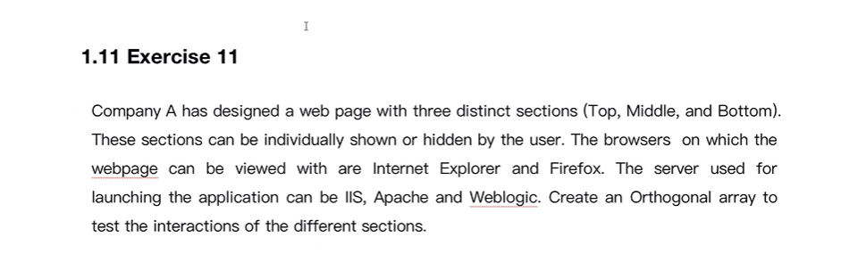

**ALL PAIR EXCERSISE**

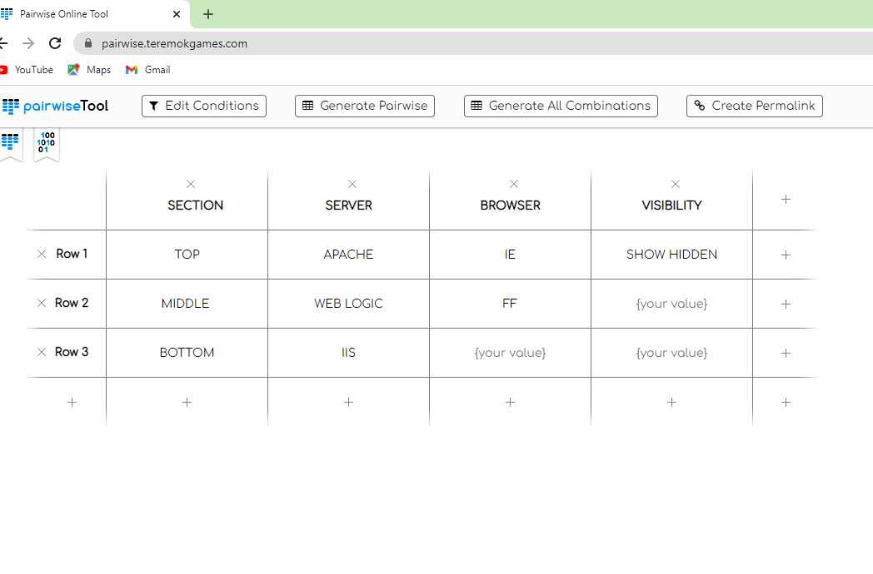

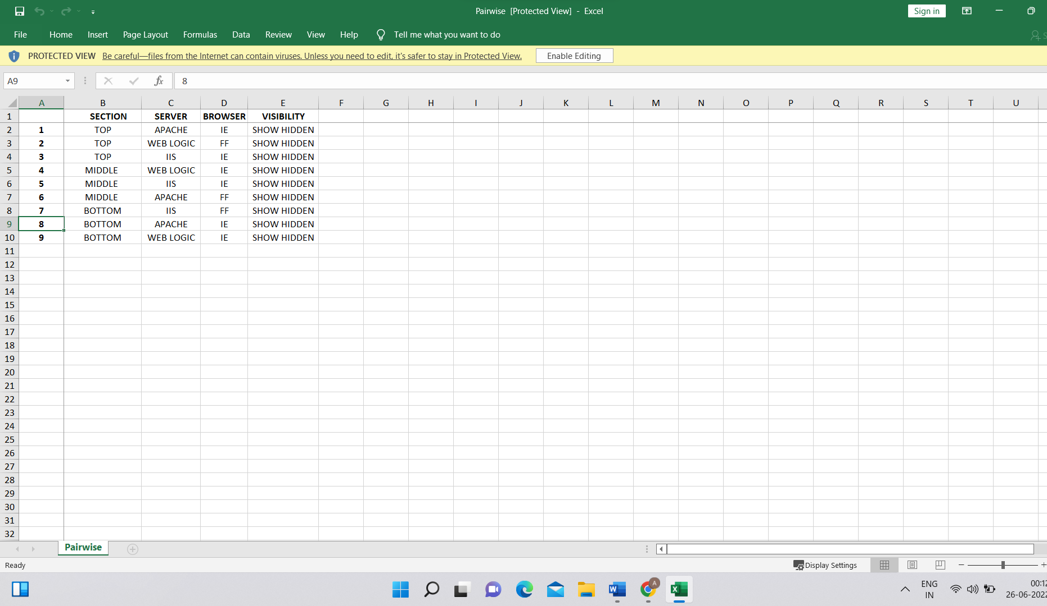

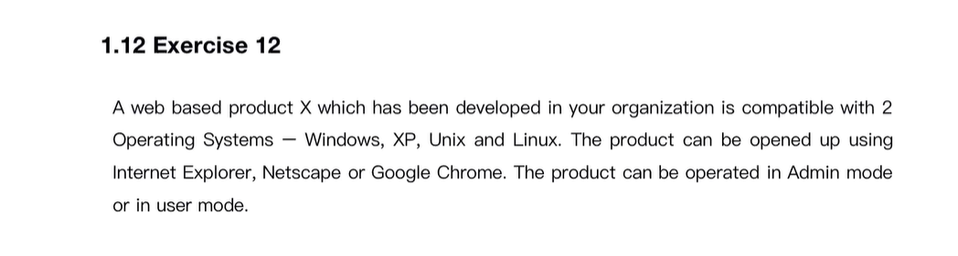

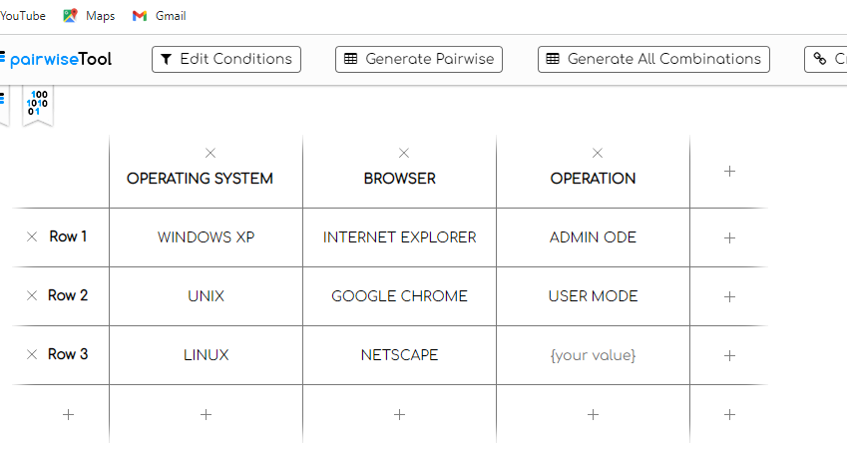

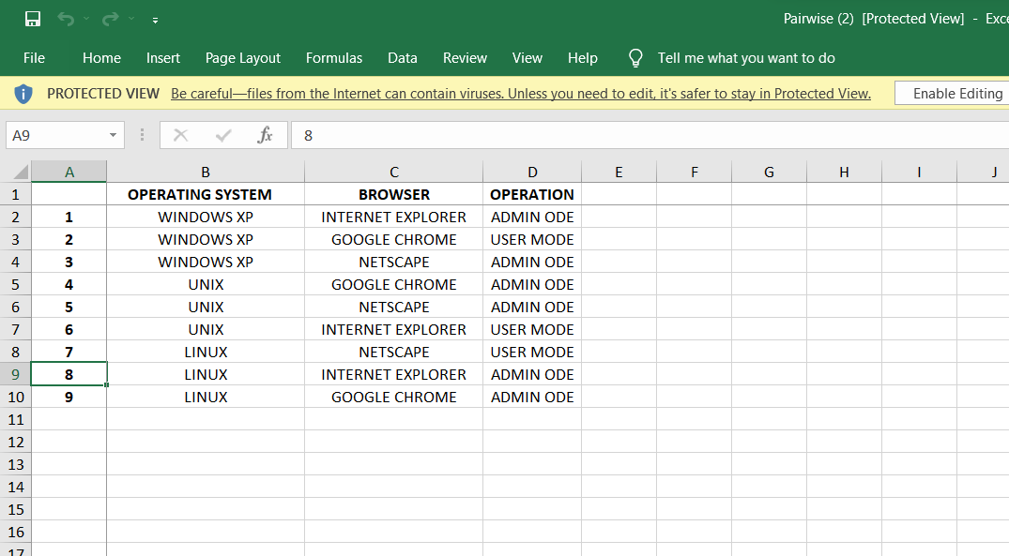

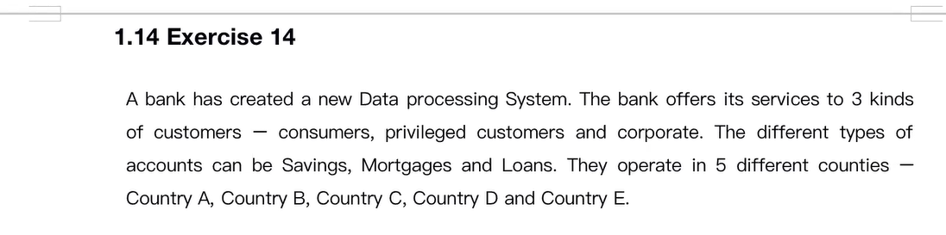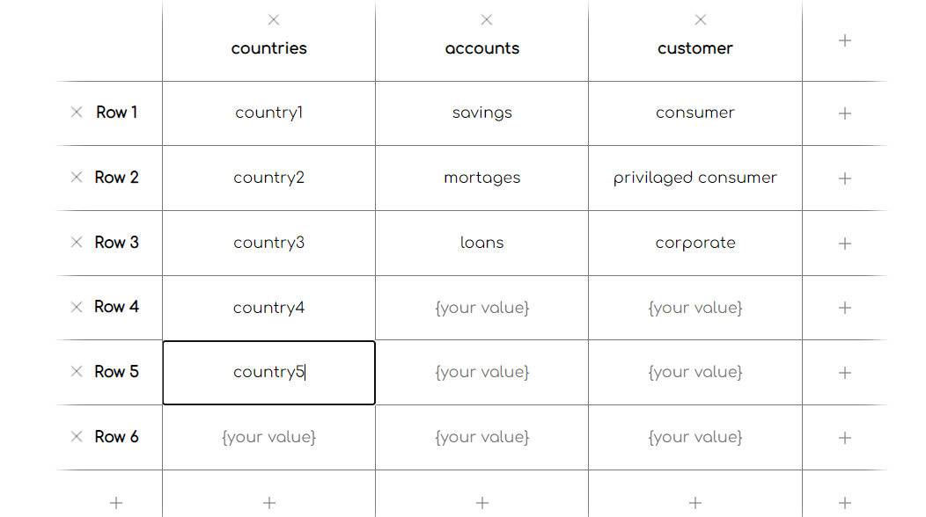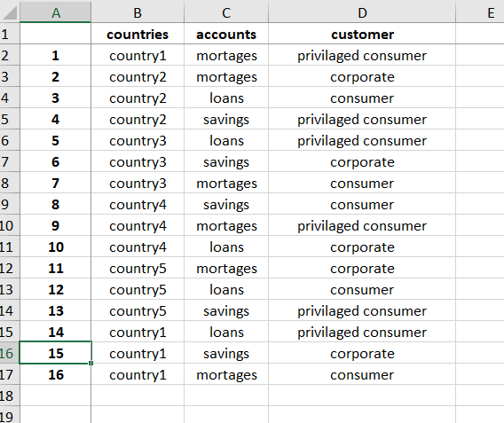

**EQUIVLALENCE PARTATIONING**

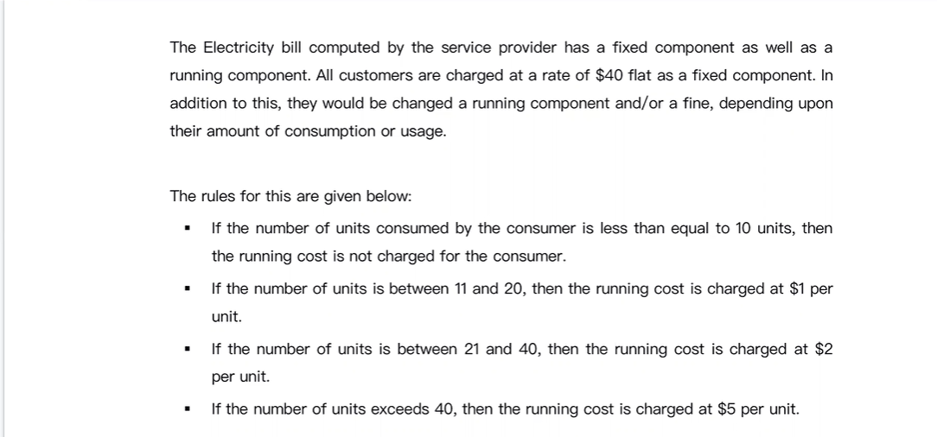

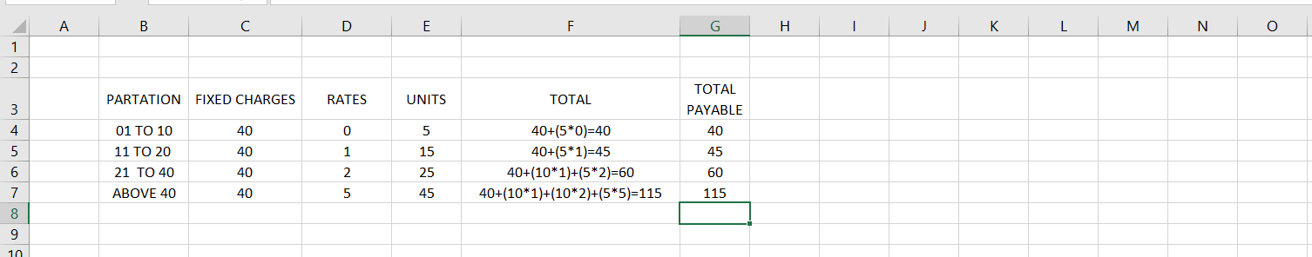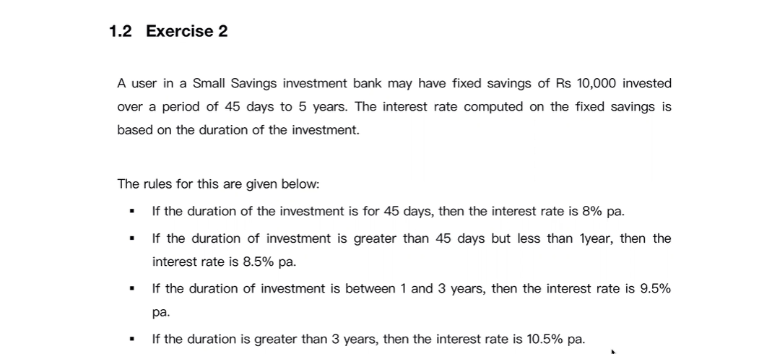

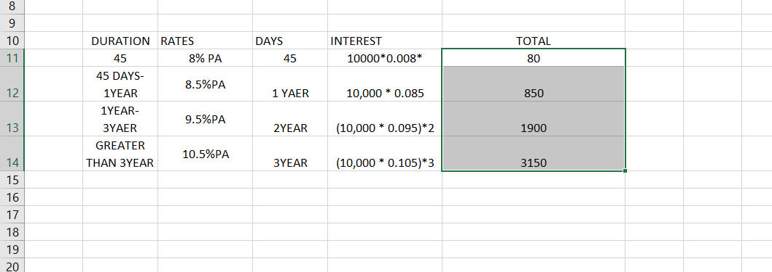

**BOUNDARY VALUAE ANALYSIS**



ANSWER:-

WE USE THE FORMULA [N .N+1,N-1]

|  |  |  |  |
| --- | --- | --- | --- |
| CONDITION | BV | BV | COMMON |
| 0-10 | 0,1 | 9,10,11 | 0,1,9 |
| 11-20 | 10,11,12 | 19,20,21 | 10,11,12,19 |
| 21-40 | 20,21,22 | 39,40,41 | 20,21,22,39 |
| ABOVE 40 | 39,40,41 | 40,41,42 | 40,41,42 |

HERE WE GET 14 BOUNDARY CONDITIONS SO WE CAN WRITE 14 COMBINATIONS AND TEST CASES

**DECISION TABLE**

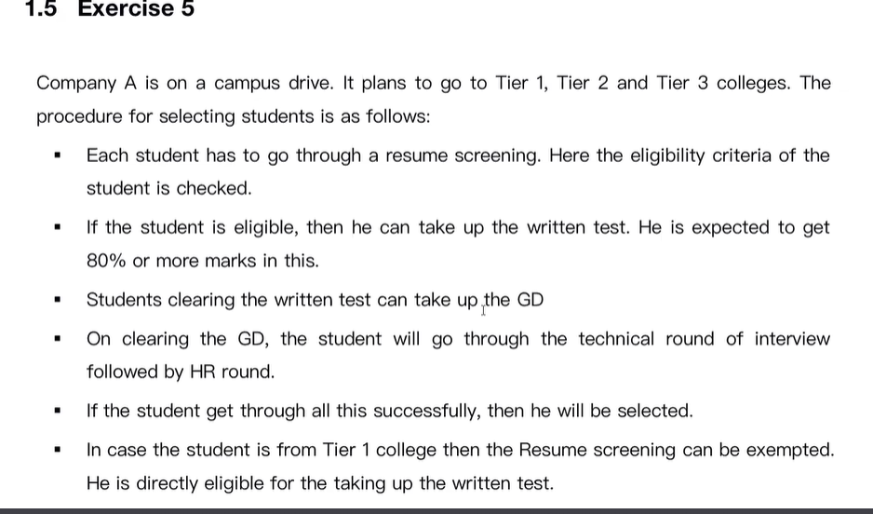

Conditions 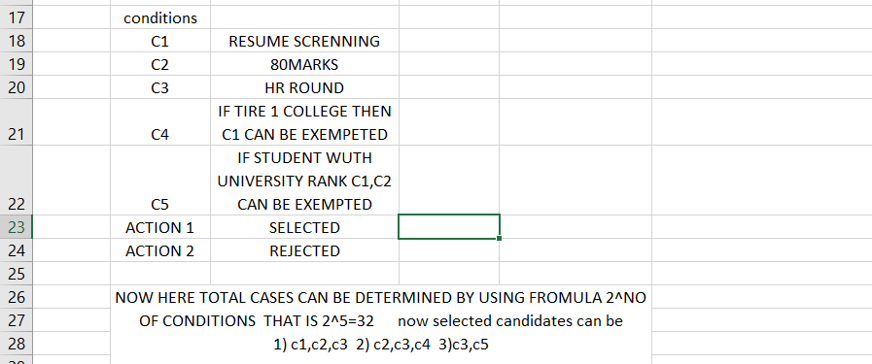

Question 2

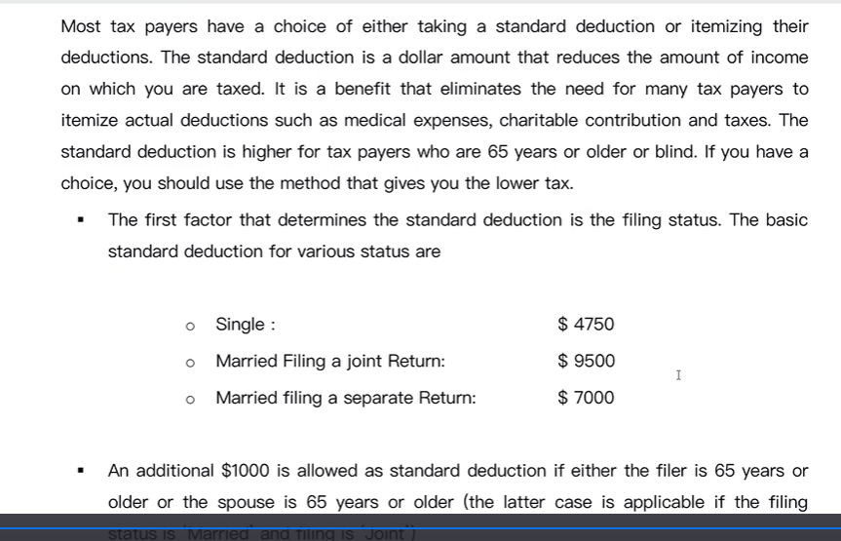

Nmber of conditions

1. Single
2. Married and paying joint
3. Married but separate
4. If myself or wife is above 65 -we get 1000 off (if we pay jointely)
5. It myself or wife anyone is blind -we get 1000$ off (if we pay jointely)

ACTIONS

1. TAX FILLINNG SINGLE EXEMPTIONS
2. JOINT NON EXEMPTIONS

RULES

1. C1
2. C2,C4,C5 -GETS 2000 OFF (TO THIS COMBINATION)
3. C2,C5 - GETS 1000 OFF (TO THIS COMBINATION)
4. C2,C4 -GETS 1000 OOFF

NO OF TOTAL CONDITIONS

2^5=32

**QUESTION 2**

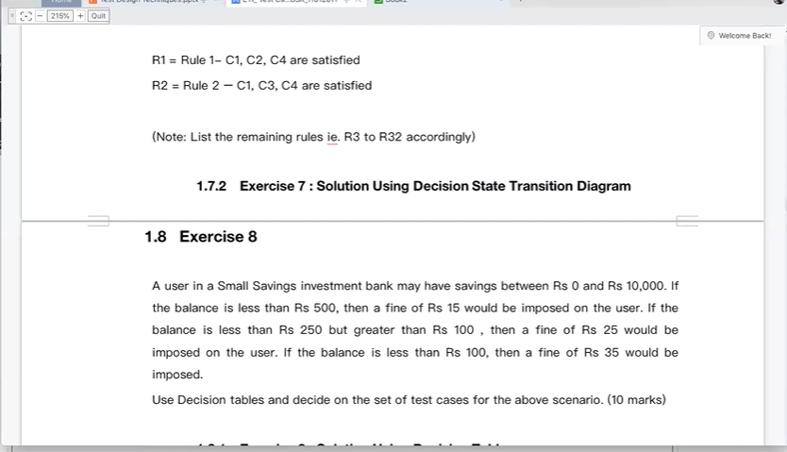

CONDITIONS

1. 0-10,000 SAVING ACCOUNT
2. IF BALANCE IS <500,FINE OF 15 ISNIMPPSED
3. IF BALANCE IS LESS THAN 101<249 ,25 FINE IMPOSED
4. IF BALANCE IS LESS THAN <100, 35 FINE IMPOSED

ACTIONNS

1. FINE
2. NO FINE

RULES

1. C2 have to pay fine
2. C3,C4
3. GREATER THAN 500 I DON’T Hve to pay any finne

2^4 = 16 so can get 16 cases

**STATE TRANSISTION**

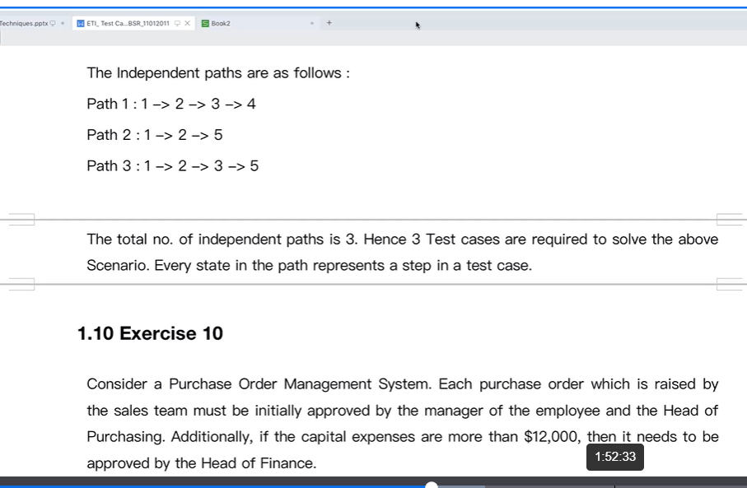

If aorder value above 1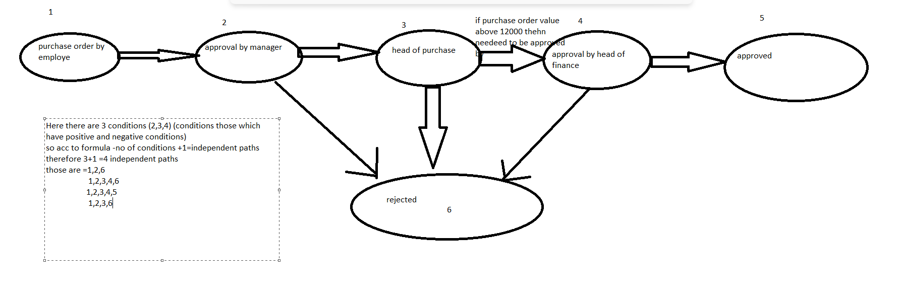

**ORTHOGONAL ARRAY**



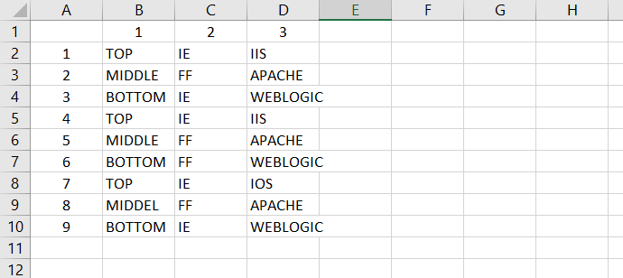

HERE EACH ROW IS A COMINATION

WE SHOULD WRITE TEST CASE OF EACH